Winshill Village Primary and Nursery School
EXCEPTIONAL LEARNING BEHAVIOURS

Executive Summary

At Winshill Village Primary and Nursery School we recognise that learning behaviour is much more than children following the rules; it is a set of skills that enable our children to access learning effectively, engage with one another positively, hold strong positive images of themselves as a learner and therefore possess a set of skills, attitudes and beliefs that will allow them to succeed now and throughout their lives.

As such, our behaviour for learning policy seeks to outline our approach to supporting every learner to develop this skillset to enable them to succeed. We believe that, in order to empower every child, a bespoke approach to every learner is required and so the bulk of our practice will not be a defined process but an overall set of values and behaviours that we collectively follow and expect of one another.

This approach is based on helping children to understand what positive behaviour looks like, how important it is for themselves and those around them and developing with them, a sense of pride in themselves and their community. We therefore form a community of respect, kindness, explanation and understanding, where we learn from mistakes by empathising with others, exploring consequences and relating this to ‘pride in the badge.’ For most learners, this enables them to flourish in a culture of growth mindset, empathy, and a commitment to try to be incredible simply because that is what they are.

We also appreciate that some of our children will require more support to achieve this. This may be due to a number of influences or experiences in their lives, and these may be current or historic. We collectively commit to a shared belief that all behaviour has a cause and seek to understand and remediate any negative experiences for children through understanding and a personalised response.

This policy is structured into two parts: the overall values and behaviours and the personalised response for learners who require additional support. It has been created with reference to numerous sources but has been fundamentally based on the EEF ‘Improving Behaviour in Schools’ research paper. Staff have crafted it collectively and so it is owned and lived by each member of the team.

The Whole School Approach (‘Pride in the badge’)

We empower positive learning behaviours through engendering pride in ourselves, our team, and our school. This is the core of our approach:
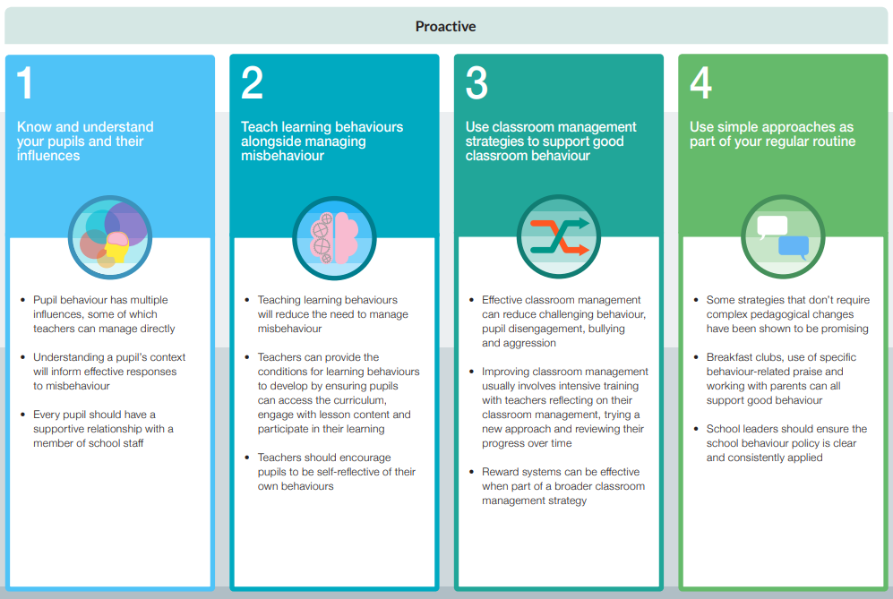
Extract from EEF ‘Improving Behaviour in Schools’

Shared Values

We:
- Understand that all behaviour, positive and negative, has a cause.
- Believe that it is critical to understand every child as an individual.
- Do not make judgements or have preconceptions about a child due to their personal circumstances but are aware that this can have an influence upon them.
- Appreciate the critical role we play in modelling, supporting, and celebrating positive learning behaviours.
- Understand that every moment of every day shapes a child’s views and beliefs.
- Believe that support, reflection, and exploration of the impact of behaviour choices is the best way to support learning positive behaviours.
- Recognise there are a range of influences on a child’s life, particularly their primary caregivers, and close, trusting connections with them are critical.
- Understand that intrinsic motivation is far more powerful than extrinsic, and that extrinsic motivation can even be detrimental to intrinsic motivation.

Commitments in action

We:
- Take the time to get to know every child and understand their contexts, beliefs, and influences.
- Commit to making sure that every minute of every day we model and support positive learning behaviours.
- Create classroom cultures steeped in growth mindset.
- Adjust practice constantly to meet the changing needs of learners.
- Set clear expectations of one another collaboratively and reflect on these regularly.
- Show pride in ourselves, the school, and our class.
- Are consistent in our approach in every class.
- Speak calmly to explore choices with children, without shouting.
- Understand our own emotions and ‘tap out’ if we feel a situation is becoming difficult to manage effectively.
- Prioritise enhancing learning behaviours and embed this in our teaching.
- Publicly endorse positive learning choices and the positive impact on others.
- Privately discuss choices that have a negative impact and agree mechanisms for remediating their impact and preventing recurrence.
- Reward exceptional effort, process, and resilience with star of the week certificates explaining the reason for our pride in the learner, not a material prize.
- Avoid the use of any sanction other than disappointment, and never use blanket punishments.
- Refer children who have made choices that have led to serious consequences (or the possibility thereof) or who are not responding to this approach to Senior Leadership and/or the Pastoral Support Team. Senior Leadership will take appropriate steps as outlined in Section 2.
- Consider the wishes and feeling of everyone involved, taking an approach of ‘what would I want for my own child?’
- Proactively seek the engagement and trust of parents and primary caregivers, including them in our discussions, processes and decisions at all points.
- Challenge one another to uphold the values.

Specific Actions
- Weekly class learning forums to explore learning behaviours and metacognition.
- Specific teaching of learning behaviours through our Leadership Curriculum or as part of EYFS provision.
- Weekly ‘Pride of Winshill’ assemblies - learners are nominate by classmates and the award is presented to them by their peers in recognition of their demonstration of the values.
- Recording negative behaviour incidents on BromCom.
- Monthly Pastoral Support Team to identify and support learners with enhanced requirement for support.
- SLT aways available at the start and end of day.
- Proactively engage parents and primary caregivers in all elements of their child’s progression wherever possible.
- Use of Behaviour Focus Recognition Board - whole class team contributing to a shared behaviour.

Use of specific structures to signal the need to change a behaviour

We recognise that sanctions have a role to play in signalling boundaries to children. However, any sanction used must help to create a change in behaviour and is not simply to punish a child.
Examples of actions used to support learners not at an enhanced level of need include:

- Reflection activities during free play periods.
- Apologies with reasoning.
- Time out to calm.
- Supported reflection.
- Restorative discussions with others involved.
This list in not exhaustive - actions appropriate to prevent recurrence for a specific incidence will be discussed with SLT and then applied accordingly.

The level at which a given behaviour is managed is dependent on the severity of said behaviour, its frequency or recurrence. Examples are given in Appendix 1.

Supporting Learners with Enhanced Need
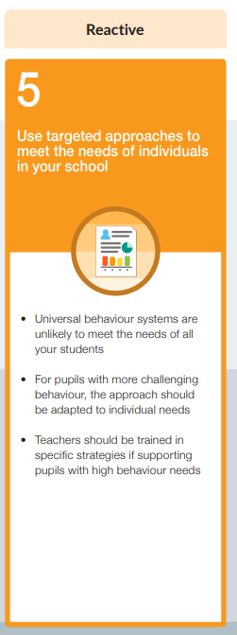

Extract from EEF ‘Improving Behaviour in Schools’

Our school is built on the belief in Limitless Possibilities for every child. This means that, for every child, we recognise our moral duty to do everything within our power to remove any barriers to learning they might have, whether environmental, educational or behavioural.

Every child carries with them life experiences and a belief system based on their interpretation of this. This internalised belief system can have both positive and negative outcomes, and we recognise that every behaviour has a root and a desired outcome. We commit to seeking to understand this for every child and responding specifically to meet their needs.

The first step to achieving this is to build a relationship with every young person, taking the time to get to know them and understand their journey to this point. This is the bedrock of all our work and precedes any further action.

We are proactive in our efforts and seek to identify and remediate additional needs before they are able to escalate.

Some learners’ needs are more acute than others and present more significant barriers to positive learning behaviour. For these learners with enhanced need, we employ a multi-professional approach to ensure balance and the best possible provision. This may include SLT, the pastoral team, parents and outside agencies as appropriate.

Having identified potential areas of need, we then use a menu of additional provision to help to address this.
Examples are listed below:
- Pastoral Support Team review.
- Longitudinal logs of negative behaviour choices to inform trends and needs for PST.
- Parental engagement.
- Graduated response (Appendix 2).
- Menu of Inclusion Strategies (Appendix 3 and 4).
- Support plans and reporting formats.
- Referral to outside agencies.
- Early Help/Family Support.
- Dual placements, including alternative provision.
- ELSA/Mental health Support.
- Counselling.
- Socially Speaking and other similar strategies.

Exclusions

We only ever use exclusion as a last resort when we have exhausted all other options or when a behaviour is so serious that a period of time to organise suitable alternative arrangements to meet that learner’s needs.

Appendices

Appendix 1: Examples of behaviour and immediate response at different levels of escalation

Level | Supported by: | Example behaviours | Possible Resolutions
Low | Class Team | Shouting out  Distracting others  Not focusing on learning  Not following instructions | - Restorative conversation during break or lunch period.  - Additional time to complete learning.  - Peer support  - Visual reminders  - Moving to a different area of the classroom to enable others to focus.
Moderate | Class/Phase | Repeated instances of the above, plus:  Arguing  Speaking disrespectfully to the teacher  Inappropriate play  Name calling | - Restorative conversation and action plan with SLT.  - Emotional awareness support and action planning.  - Reflection time.  - Verbal reminders  - Working in a different classroom.  - Parental engagement
High | Senior Leadership | Repeated instances of the above, plus:  Fighting or hurting other children  Swearing  Refusal to follow instructions from teacher | As above plus:  - Extended time period away from peers.  - Parental meeting with class teacher and SLT.  - Changing structure of day, learning etc.
Extreme | Headteacher or DHT in HT’s absence | Racist/homophobic comments  Confirmed Bullying  Violence or aggression towards children or staff  Refusal to follow instructions from Senior Leadership  Threatening to abscond  Other extreme behaviours | - Immediate parental inclusion.  - Time out of school.  - Separated learning.  - Consideration of exclusion.

Appendix 2: Graduated Response (Pastoral)

Tier 3

Continue to monitor and support through Pastoral Support Team meetings.

Refer for counselling in school.

CAHMS referral to be made.

Parents to be regularly updated with drop-in sessions to be offered.

EHA forms to be completed for multi-agency support.
Tier 1

Monitor social and emotional well-being of class members.

Establish a positive and engaging school climate.

Identify and address barriers – invite parents in for an informal meeting.

Complete Pastoral Referral Form.
Tier 2

Provide personalised support (ELSA).

Refer concerns to Pastoral Support Team to monitor.

Signpost parents to external support agencies – refer to Family Support.

Alternative provision to be considered.

TAC Meetings to be arranged to support family and learner.

Completed EHA referrals.

Appendix 3: Menu of Inclusion Strategies - specific areas of need

Tier 2
ELSA (30 mins session – x1 for 6 wks)
Strategies to support building friendships.

Aims:
To identify key qualities of friendships.
To understand the responsibilities within friendships.
To accept that friendship is a two-way process.
.
Lego Play (x1 week 30 mins 3 per group)

Aims:
To develop listening.

To encourage turn taking.

To encourage teamwork.

ELSA (30 mins session – x1 for 6 wks)
Strategies to build confidence and self-esteem.

Aims:
To recognise personal qualities/strengths.
To confidently contribute to class discussions.
To develop a resilient approach.
ELSA (30 mins session – x1 for 6 wks)
Strategies to support emotional regulation.

Aims:
To recognise and talk about emotions.
To recognise physical signs of anger.
To develop coping strategies.

Rainbow Hub (x1 week 1 hour)
Learners who require additional support.

Aims:
To provide learners with a bespoke personalised programme of learning based on needs – adopting a practical approach.
To develop kills related to listening and working together.
ELSA (30 mins session – x1 for 6 wks)
Strategies to develop social skills.

Aims:
To increase awareness of feelings and responses.
Ability to communicate with others and share ideas.
To develop listening and turn taking.

Lunch Time Club
(30 mins sessions – x1 for 6 wks)

Aims:
To develop listening.
To encourage turn taking.
To encourage teamwork.

To provide support during unstructured times of the day and offer support with building friendships.
Family Learning Project (4-week session 1 hour)

Aims:
To increase parental engagement.
To model positive relationships.
Develop communication skills.
Model appropriate behaviours.

Forest School
(30 mins sessions – x1 for 6 wks)

Aims:
To provide hands-on experiences in the natural environment. To encourage creative learning and develop children's confidence as they problem-solve and learn to manage risks.
Jellybean Jamboree (30 mins sessions – x1 for 6 wks)

Aims:
To develop life skills necessary for social and emotional growth focusing on anger management, emotional awareness, decision making, self-control, friendship skills, and behaviour.

Tier 3

Outside Agency Support
(Early Help)

Family support – referral and EHA to be completed.
Counselling

1:1 support over 6 weeks, followed by ELSA support

Outside Agency Support (Malachi)

Referral and EHA to be completed.

Appendix 4: Menu of Inclusion Strategies - general behavioural support strategies

Learner begins to present persistent challenging behaviours in the classroom/outside.

Personalised social/emotional targets on PDR (if SEND).
Behaviour reward chart – monitored and managed by inclusion team.
Start of Early Help Action Plan to catalogue support.
Formal TAC meeting with parents – reviewed regularly (monthly).
Tier 2 Pastoral Support interventions e.g., socially speaking, Jellybean Jamboree.
In-class behaviour reward chart – monitored and managed by the class-teacher.
Initial formal discussion with parents to establish plan of support.
Reasonable adjustments made to class structures to enable success.
Review of whole class behaviour management strategies.

Access to Nurture activities for break time and lunch times.
Access to Nurture activities in times of crisis, identified triggered points.
Tier 3 in school pastoral support – counselling.
Chunked timetable in-class with regular reviews and rewards in place.
Positive Behaviour Plan created to identify the cause of behaviours and plan actions to support.
Parents signposted to external partners who may be able to support. (Tier 2 referrals).
SEN: PDR reviewed.
Non-SEN: Individual Behaviour Plan created.
Advice SEND Hub is SEN concerns are raised.
Tier 2 alternative provision – gardening, cooking, games to develop social skills.

Behaviour Reward Chart (if appropriate) monitored by SLT – stepping away form policy if needed.
Continuation of TAC meetings – professionals invited (fortnightly).
School to request external agency support e.g., Ed Psych, CAHMS, CYAS.

Tier 3 in school specialist learning support.
Return to learn strategies reviewed and refined (weekly).
TAC Meetings reviewed weekly – professional invited and outcomes shared.
Safeguarding ramifications to be considered and reviewed if phased/part-time.
Phased Return to be considered (not exceeding 3 weeks).
Return to learn plan to be created and reviewed with parents in daily meetings.
Completely personalised provision – chunked day and continuous provision.
Return to classroom-based learning plan to be agreed and regularly reviewed.
Consider learning outside of the classroom environment – alternative provision.
Fixed term exclusion – period to be agreed (not exceeding 5 days)
Return to learn plan to be created because of Internal Exclusion to ensure successful inclusion.

Internal Exclusion – period of time out of class to be agreed (not exceeding 5 days).
Part Time learning options to be considered (with parental consent).
EHCP Request if appropriate.

Weekly TAC meetings to be held – all professionals to attend.
Managed move to be considered.
Risk of exclusion meeting – seek alternative provision (inc. short stay) and support.

Permanent Exclusion.

Appendix 5: Class/Serious Incident Recording Sheets

To be created on BromCom.
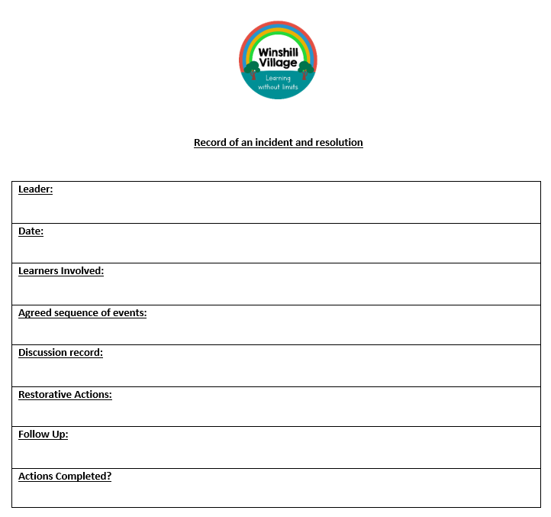

Appendix 6: Pastoral Support Team Referral Form

